Problem: We need good forecasts of mortality and fertility rates by age (e.g., death rates at age 60 in 2030).
This is hard because: Rates change over age and over time, the age curves are noisy, especially at very young and very old ages, some years are abnormal (wars, epidemics like the 1918 flu), traditional methods (like Lee–Carter) are too rigid and not robust to outliers.
The paper proposes a better forecasting method that is: Smooth, flexible, robust to abnormal years, and more accurate in practice.

The key idea: Treat each year’s age-specific mortality or fertility rates as a smooth curve, break those curves into a few main patterns, forecast how those patterns change over time, and ignore extreme years when learning the patterns.

How the method works (step by step)
1. Think in curves, not tables
Instead of treating mortality as many separate time series (one per age), the authors assume that each year has an underlying smooth curve over age and the observed data are noisy measurements of that curve. So, for each year, they smooth the data across age.
Our observations are $\{x_{i}, y_{t}(x_{i})\}, t = 1, . . . , n, i = 1, . . . , p ,$​$y_{t}(x_{i})$= log {rate at age $x_{i}$in year t} where

$$y_{t}(x_{i}) = f_{t}(x_{i})+σ_{t}(x_{i})ε_{t,i } (1)$$

$ε_{t,i}$is an iid standard normal random variable and $σ_{t}\left(x_{i}\right)$ allows the amount of noise to vary with x. Also, $f_{t}\left(x_{i}\right)$ is an unknown smooth function of age and data are observed discretely and with heteroskedastic noise.
The goal is to forecast $f_{n+h}(x)$ (and hence $y_{n+h}(x)$) for h≥1. Typically, $x_{1},..., x_{p}$ are single years of age ($x_{1}=0, x_{2}=1,...$)
2. Use sensible constraints when smoothing (Functional smoothing)
To make the curves realistic: Mortality curves are forced to be increasing at older ages. And, fertility curves are forced to be concave (rise then fall). This removes random noise where data are unreliable.
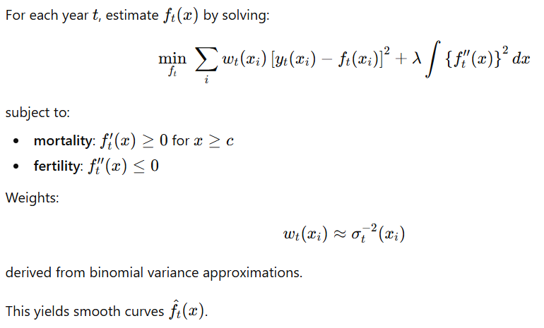

3. Find the main ways curves change (functional PCA)
After smoothing, they decompose the curves into: An average age pattern and a few key components (basis functions) that describe how curves differ. This is like PCA (Karhunen–Loève expansion), but applied to functions (curves) instead of vectors.
Example intuition: One component might describe changes in child mortality. Another might describe older-age mortality. For fertility, components capture shifts toward earlier or later childbearing.
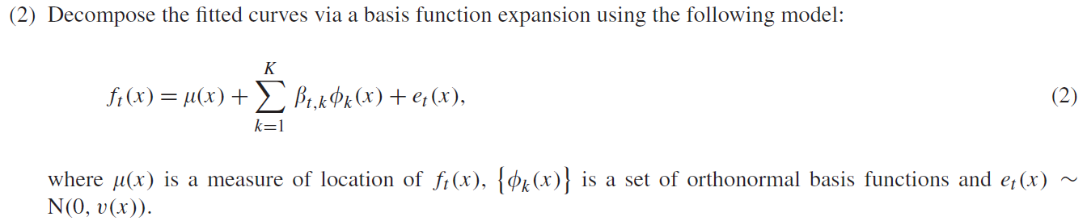

4. Make it robust to wars and epidemics
Some years (e.g., World Wars, Spanish flu) look very different. Solution: Down-weight or exclude abnormal years when estimating the main patterns, or let those years show up as outliers in time-series models instead. This prevents rare disasters from distorting long-term trends. In Robust functional PCA: 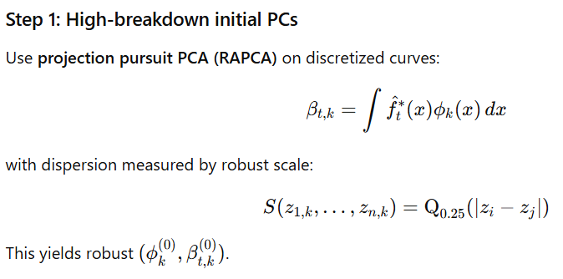
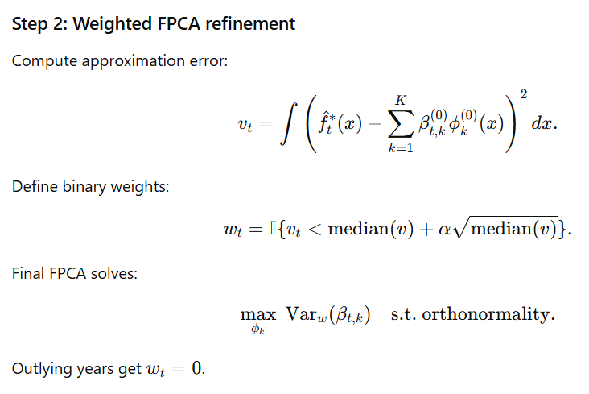

5. Forecast only a few time series
Each curve is summarized by a small number of coefficients (usually 3–4). We can fit robust ARIMA models to each coefficient and forecast those coefficients forward in time. This is much simpler than forecasting hundreds of age-specific series.
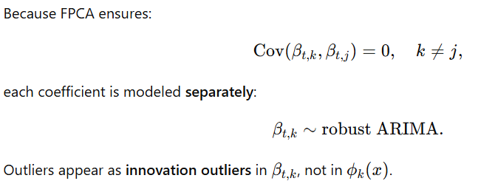

6. Rebuild future curves + uncertainty
Finally, we combine forecasted coefficients with the age patterns, produce future mortality or fertility curves and construct prediction intervals that include all sources of uncertainty.
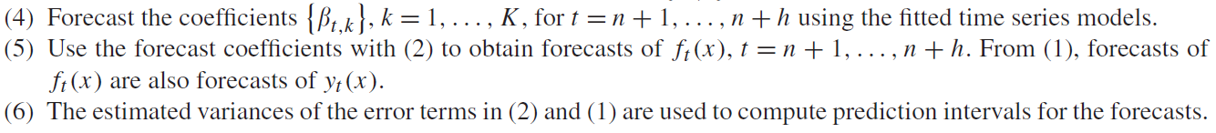
Forecast reconstruction:
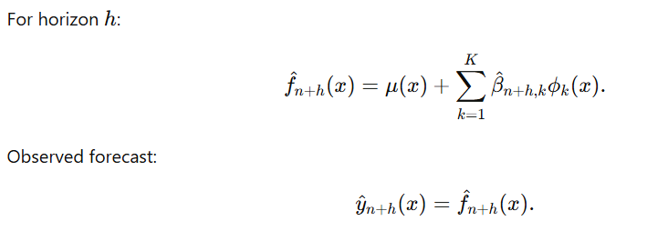
Forecast variance:
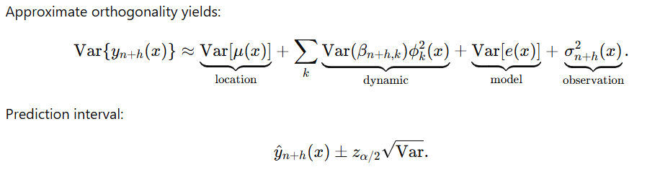
The paper proposes a robust, constrained, finite-rank functional time-series model for age-specific demographic rates, estimated via smoothed functional PCA and forecast via robust univariate ARIMA models.

Application:
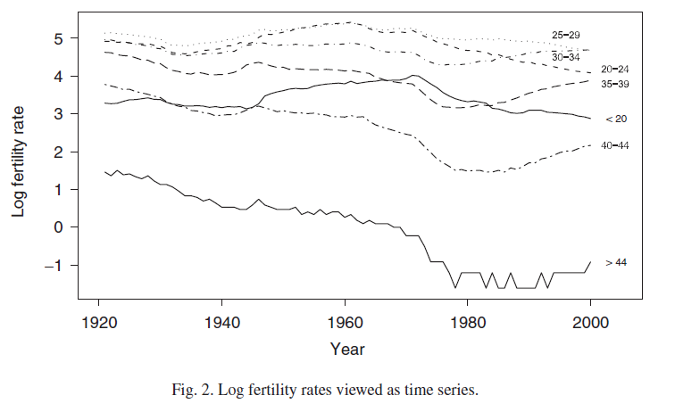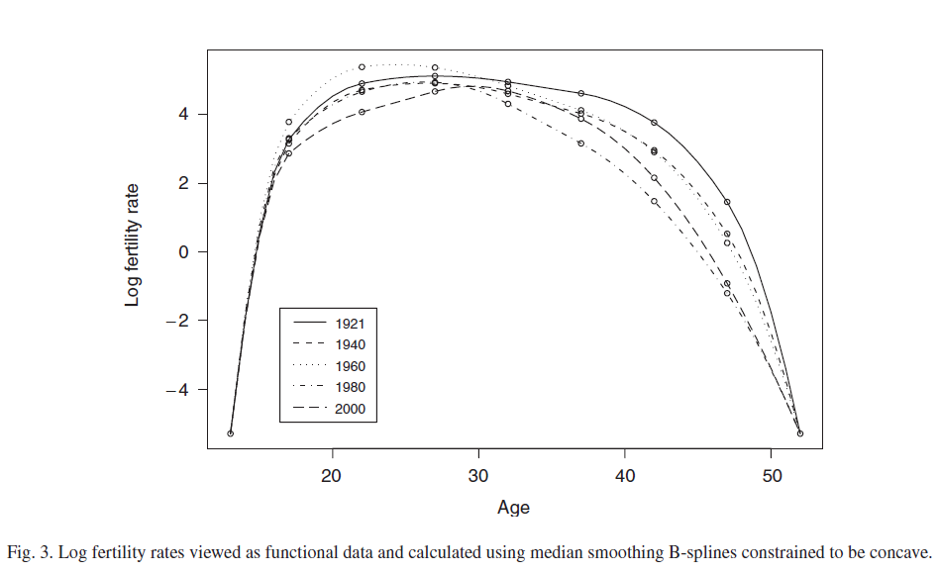

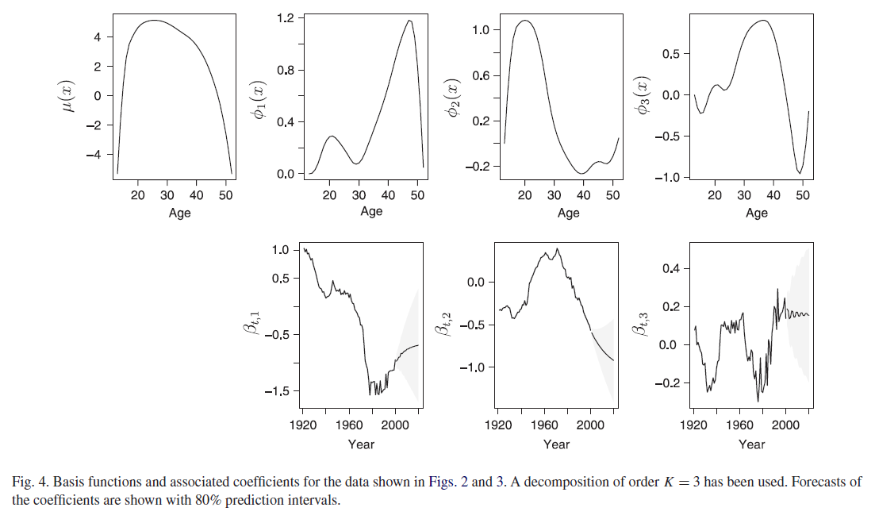
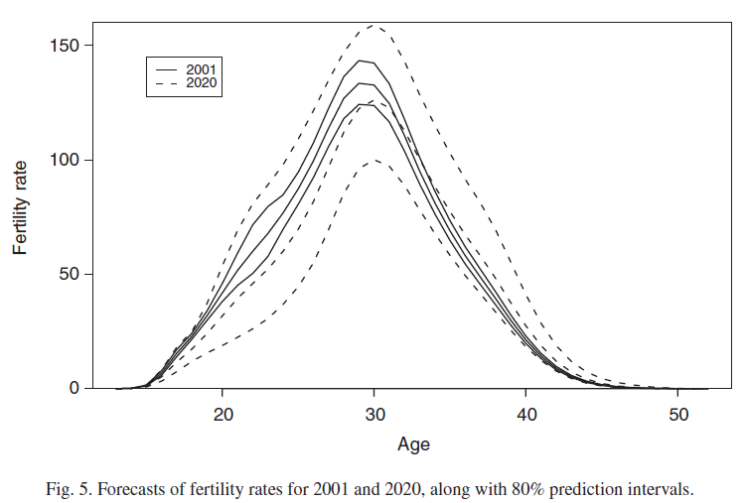

Functional Time Series Dataset in ftsa package:
A functional time series (FTS) is a sequence of functions observed at regular time intervals. Instead of measuring a single value each period (like stock price, temperature, etc.), you observe a whole curve, e.g., a measurement that varies over age, time of day, spatial location, etc. Think of each time point as a curve or profile rather than a scalar. R Project Search
In the ftsa package, the data are usually stored as matrices, where rows represent time points (e.g., years), and columns represent the values of the function at fixed locations on the domain (e.g., ages 0–100 or hours 1–24). So, the entire function observed at time t is one row of that matrix.
Mortality Log-Rates (all_hmd_female_data, all_hmd_male_data):
Each year’s entire age-profile of log mortality rates (ages 0–100+) is treated as a functional observation. So, at time t (say year 1980), the function is mortality vs. age, one full curve. The dataset stacks hundreds of these curves (one per year and per state). A n*p matrix with n=186 observations on the following p=101 ages from 0 to 100+. They correspond to 62 (number of years) times 3 (states). Each FTS contains 101 functional values.
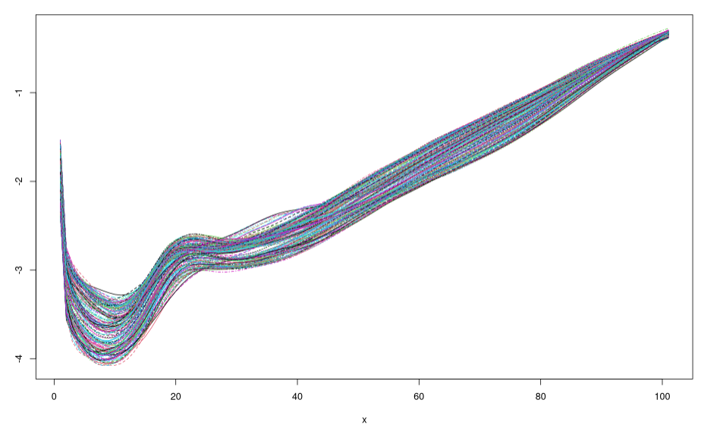

Expanding the idea to FAE:
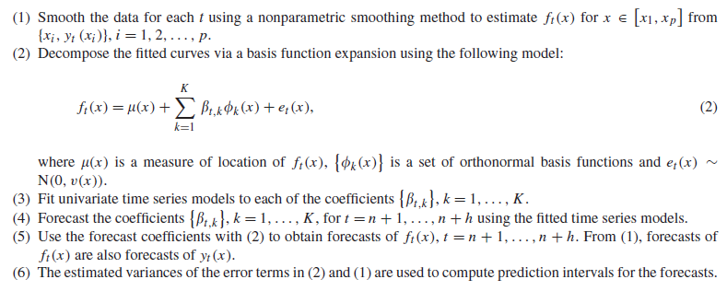
This algorithm takes the PCA coefficients and implements the time series and then continues the rest of analysis using the predicted coefficients. In FAE, we have rep in the latent space as our PC and the following architecture:
We can use this idea on the coefficient layer.

